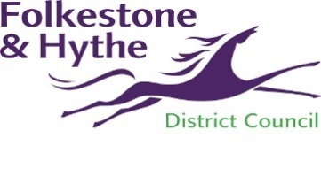

**NOTICE OF APPLICATION FOR A MINOR VARIATION**

**TO A PREMISES LICENCE**

LICENCE HOLDER:

PREMISE NAME/ADDRESS:

An application has been made for a Minor Variation of the premises licence at the above premises.

Details of variation including activities, days, time

Details of the application PR - may be viewed online <https://folkestonehythedc.force.com/pr/s/rs-home> or by appointment at the Civic Centre (call 01303-853660 to arrange this).

Any interested party or responsible authority may make representations in respect of the application, in writing, to the below address, or by email to [licensing@folkestone-hythe.gov.uk](mailto:licensing@folkestone-hythe.gov.uk) or by commenting on the application online before the date below.

This notice remains in force from ------------ for 10 working days until, and including, ---------------

It is an offence knowingly or recklessly to make a false statement in connection with an application. The maximum fine on summary conviction is £5,000

Licensing Team, Folkestone & Hythe District Council, Civic Centre, Castle Hill Avenue, Folkestone, Kent CT20 2QY

[www.folkestone-hythe.gov.uk](http://www.folkestone-hythe.gov.uk/)