**Folkestone & Hythe**

**District Council**

**Home Essential Fund**

**(UK Prosperity Fund Project)**

**Policy**

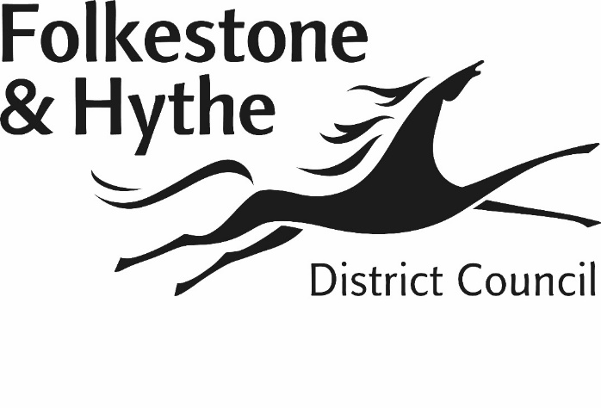

**Contents**

|  |  |
| --- | --- |
|  | **Page no.** |
| 1. Background | 3 |
| 1. Equalities | 4 |
| 1. Purpose of the UK Prosperity Fund | 4 |
| 1. Eligibility Criteria | 5 |
| 1. The UK Prosperity Fund process | 5 |
| 1. Making an award under the UK Prosperity Fund | 6 |
| 1. Publicity | 7 |
| 1. Appeals | 7 |
| 1. Fraud | 7 |
| 1. Complaints | 7 |
| 1. Policy Agreement and Review | 8 |
|  |  |
|  |  |
|  |  |
|  |  |
|  |  |

**1 Background**

1.1 This document sets out Folkestone & Hythe District Council’s (‘the Council’s’) approach to supporting people through the additional funding from the Government’s UK Shared Prosperity Fund.

1.2 The UK Shared Prosperity Fund (UKSPF or the Fund) is a central pillar of the UK government’s ambitious Levelling Up agenda and a significant component of its support for places across the UK. It will help places right across the country deliver enhanced outcomes and recognises that even the most affluent parts of the UK contain pockets of deprivation and need support.

1.3 Guidance sets out a multitude of interventions and objectives. Full details can be found online:

[www.gov.uk/government/publications/uk-shared-prosperity-fund-interventions-outputs-and-indicators](http://www.gov.uk/government/publications/uk-shared-prosperity-fund-interventions-outputs-and-indicators)

Folkestone & Hythe District Council have decided to focus their attention on objectives E11, E13 and E39. This policy focusses on the interventions under E13 to ‘reduce the cost of living, including through measure to improve energy efficiency, and combat fuel poverty and climate change.

1.4 Folkestone & Hythe District Council aims to support residents for an extension of the funding from 1 August 2025 to 31 March 2026 or until funds are exhausted.

1.5 The objectives of the policy will be to:

* To provide support to vulnerable households recognising the profile and specific needs of residents, in particular those who have been most adversely impacted by rising fuel costs.
* To support households and prevent household needs from escalating into crisis.

1.6 Funding received by Folkestone & Hythe District Council will be made available to support households in 1 key area:

* To replace broken or inefficient white goods (fridge/freezers, washing machines, microwaves, cookers and other items if appropriate) to reduce ongoing costs and improved energy efficiency.

Applications where landlords have a duty to provide the services above will not be considered.

1.7 The total expenditure in this period resulting from awards under this scheme will not exceed the value of the funding available.

**2 Equalities**

2.1 The creation of a UK Prosperity Fund Policy facility meets the Council’s obligations under the Equality Act 2010.

2.2 The Council recognises the impact of rising living costs and its economic consequences on our most vulnerable residents and therefore the importance this policy has in protecting those applicants most in need from financial support.

2.3 Applicants will also be offered further support as applicable via other schemes managed by the Council as well as appropriate signposting to other relevant services if required.

**3 Purpose of the UK Prosperity Fund**

3.1 The full objectives of the UK Prosperity Fund can be found online on their prospectus:

[www.gov.uk/government/publications/uk-shared-prosperity-fund-prospectus](http://www.gov.uk/government/publications/uk-shared-prosperity-fund-prospectus)

This policy will focus on providing support to vulnerable residents on a low income where alternative sources of assistance may be unavailable.

3.2 All applications will be treated on their individual merits based on the information and supporting evidence provided in conjunction with consideration of the available funds. This may mean that not all applications can be agreed.

3.3 An award will usually be a one-off provision to support a household in need and ease the burden faced by a wide range of vulnerable households across the country worrying about paying the next utility bill.

The grant will be used with the intention of:

* preventing serious risk to the health, well-being or safety of the area’s most vulnerable and financially excluded residents.
* easing severe financial pressure caused by current economic pressures.

3.4 Priority will be given to cases with immediate need. Further advice may also be offered such as benefit eligibility and signposting to other agencies as appropriate.

**4 Eligibility Criteria**

4.1 To be eligible for an award through the UK Prosperity Fund, you must:

* live in Folkestone & Hythe District,
* be aged 16 or over,
* be in receipt of benefits or be on a low income (such as minimum wage). Accepted benefits can be found below.
* not have access to any funds that can be relied on to meet the need you are applying for, and where you would be left with insufficient resources which would cause serious risk to your own, or your family’s, health, or safety.

4.2 Accepted benefits to meet criteria are:

* Universal Credit
* Working Tax Credit/Child Tax Credit
* Employment and Support Allowance
* Jobseeker’s Allowance
* Income Support
* Pension Credit
* Housing Benefit
* Council Tax Reduction

4.3 Applications for items that are covered under tenancy agreements will not be considered as this would be a landlord’s duty to supply the service, for example, replacement boilers or white goods if included in the inventory.

**5 The UK Prosperity Fund process**

5.1 An application for an award may be made via a self-referral or via a request from a Council officer, councillor or voluntary or community organisation. An application can be made by completing the UK Prosperity Fund form via the Council’s website. Applications may also be awarded if a resident has been identified as having a need via application for other support, such as the Household Support Fund, Council Tax Reduction or contact with the Council’s Welfare Team.

5.2 Applications from people not meeting the minimum eligibility criteria will not be considered.

5.3 In some cases the Council may use information held to make an award in the absence of an application form.

5.4 It is the applicant and referrer’s responsibility to ensure that the correct items/services are requested at the time of requesting an award, additional items cannot be added at a later date, except in the situation where there is an unforeseen issue.

5.5 It is the responsibility of the referrer to collate and provide evidence in support of the application. Failure to do so will result in a delay with the application being assessed and a decision could be made in the absence of supporting information which could result in requested items/service not being awarded.

Evidence should be provided electronically via the online UK Prosperity Fund form. If a resident does not have access to the internet support can be offered by contacting the Council or a local community hub.

5.6 The Council may request any other reasonable evidence in support of an application for a UK Prosperity Fund award. The applicant or referrer will be asked to provide the evidence and it must be provided within two weeks of the request although this will be extended in appropriate circumstances.

5.7 The Council reserves the right to verify any information or evidence that the applicant supplies, in appropriate circumstances, with other Council departments, government agencies and external organisations or individuals. We may also use the information for the detection/prevention of fraud.

5.8 If the applicant is unable to or does not provide the required evidence, in the agreed time, we may treat the application as withdrawn by the applicant and we will not be under an obligation to assess it.

5.9 In applying this policy, the decision maker will take into account any alternative funding provision including Discretionary Housing Payments and Financial Support Payments.

5.10 The Council may request details of an applicant’s household income and expenditure in the process of making a decision.

5.11 The possible outcome of an application is to award fully, partially or not at all.

**6 Making an award under the UK Prosperity Fund**

6.1 The Council will decide whether or not to make an award from the UK Prosperity Fund, and how much any award might be. Awards will be given in the form of an item. This is detailed below:

* White good provision will be awarded in partnership with a chosen supplier. This will be an affordable and energy efficient item (as available at the time). This service will include delivery, fitting and removal of old items.

6.2 A previous award under the UK Prosperity Fund under one category does not guarantee that a further award will be made at a later date for another item, even if the applicant’s circumstances have not changed.

6.3 The Council will notify the applicant of the outcome of their request on the day the decision is made. This may be by letter, telephone, email, SMS (text) or a combination of these methods.

6.4 Where the request for an award is unsuccessful or not met in full the Council will explain the reasons why the decision was made.

6.5 The Council may, with the applicant’s permission, also inform a support worker, or another organisation where that organisation may be able to help the applicant, of a decision.

**7 Publicity**

7.1 The Council will make a copy of this policy available for inspection and will be published on the Council’s website.

7.2 The Council will also share details of the scheme with local press and on social media channels.

**8. Appeals**

8.1 UK Prosperity Fund awards are not subject to a statutory appeals process. Appeals will therefore be decided by the Council as part of its normal complaints process.

**9. Fraud**

9.1 The Council is committed to protect public funds and ensure funds are awarded to the people who are rightfully eligible to them.

9.2 An applicant who tries to fraudulently claim an award by falsely declaring their circumstances, providing a false statement or evidence in support of their application, may have committed an offence under The Fraud Act 2006.

9.3 Where the Council suspects that such a fraud may have been committed, this matter will be investigated as appropriate and may lead to criminal proceedings being instigated.

9.4 In the event that it comes to the Council’s attention that a grant has been awarded as a result of misleading information, deception or fraud the Council will seek repayment of the monetary value of the grant from the recipient.

9.5 Where it comes to the Council’s attention that the applicant has received a grant, payment or loan from another source for the same purpose as that for which a grant has been awarded under this policy, the council may seek repayment of the monetary value of the grant.

**10. Complaints**

10.1 The Council’s Complaints Procedure (available on the Councils website) will be applied in the event of any complaint received about the application of this policy.

**11. Policy agreement and review**

11.1 This policy will be agreed and reviewed in line with any changes in legislation. Alterations to the policy will be approved by Folkestone & Hythe District Council’s Director of Corporate Services in consultation with the Cabinet Member for Revenues, Benefits, Anti-Fraud and Corruption.

July 2025