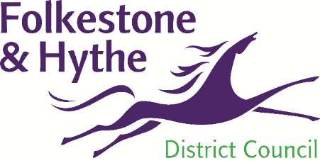
Licensing Team

Folkestone & Hythe District Council

Civic Centre, Castle Hill Avenue

Folkestone

Kent CT20 2QY

01303 853 660

licensing@folkestone-hythe.gov.uk

www.folkestone-hythe.gov.uk

Notice of Application FoR A Minor variation to a Premises Licence

Notice is given that an application has been made to Folkestone & Hythe District Council, the Licensing Authority for a;

PREMISES LICENCE – MINOR VARIATION

to permit licensable activities which it is proposed will be carried out, on or from the premise shown below.

NAME OF APPLICANT

NAME AND POSTAL ADDRESS OF THE PREMISES

DETAILS OF PROPOSED VARIATION (Must include activities, days and times being changed)

Any interested party or responsible authority may make representations in respect of the application, in writing, to the below address, or by email to licensing@folkestone-hythe.gov.uk, before the date below.

This notice remains in force from ___________ for 10 Working days until, and including, ___________

It is an offence knowingly or recklessly to make a false statement in connection with an application. The maximum fine for which a person is liable on summary conviction for the offence is unlimited.

